Power of Authorities and Trust in Authorities Determine the Interaction Climate and Tax Compliance

Katharina Gangl, Eva Hofmann, Barbara Hartl, and Erich Kirchler
University of Vienna, Austria

Taxpayers differ in their tax compliance depending on the interaction climate between tax authorities and taxpayers. The present study investigates mechanisms underlying the interaction climate - such as power of authorities and taxpayers’ trust in authorities – resulting in enforced compliance, voluntary cooperation or committed cooperation. Results show that enforced compliance depends on coercive power whereas voluntary cooperation depends on legitimate power of tax authorities. Committed cooperation was found to originate in a confidence climate which is characterized by mutual implicit trust and a moral obligation to cooperate. Concluding theoretical and practical implications are presented, on how to strengthen taxpayers’ voluntary and committed cooperation.

E-mail contact: k.gangl@univie.ac.at, eva.hofmann@univie.ac.at, barbara.hartl@univie.ac.at, erich.kirchler@univie.ac.at; Postal address: University of Vienna, Faculty of Psychology, Universitaetsstrasse 7, 1010 Vienna, Austria.

Acknowledgement: We thank Stefanie Lietze and Lauri Metz for their assistance with data collection. This study was partly financed by the Austrian Science Fund (FWF), project number P24863-G16.

Power of Authorities and Trust in Authorities Determine the Interaction Climate and Tax Compliance

Introduction

Tax authorities influence tax compliance of citizens in various ways. According to the Slippery Slope Framework, tax authorities applying power measures enforce tax compliance whereas tax authorities who are trusted by the taxpayers gain voluntary cooperation (Kirchler, 2007; Kirchler, Hoelzl, & Wahl, 2008). Power deals with pressure through audit probabilities and fines (Allingham & Sandmo, 1972; Blackwell, 2010), whereas trust originates in perceived benevolence of the authorities, transparency and fairness of tax law, tax collection procedures, and tax burden (Braithwaite, 2003b; Wenzel, 2002, 2004). The Slippery Slope Framework treats power and trust as independent dimensions determining taxpayers’ behavior. The extended Slippery Slope framework, however, takes into account the dynamics between power and trust that result in different interaction climates between tax authorities and taxpayers and different forms of tax compliance (Gangl, Hofmann, Pollai, & Kirchler, 2012). The present paper empirically tests the extended Slippery Slope Framework by analyzing the dynamics between power and trust underlying the interaction climates and enforced compliance, voluntary and committed cooperation.
The extended Slippery Slope Framework differentiates between different qualities of power and different qualities of trust (Gangl et al., 2012). Departing from the theory of bases of social power (French & Raven, 1959; Pierro, Raven, Amato, & Bélanger, 2012; Raven, Schwarzwald, & Koslowsky, 1998) the framework distinguishes between coercive power and legitimate power. While coercive power is manifested through severe controls and punishment of tax evaders and rewarding of cooperative tax behavior, legitimate power means that authorities are accepted as legitimized to give orders and are perceived as holding expertise and behaving professionally when providing information and establishing rules of conduct. Trust is defined in the context of the socio-cognitive trust theory and differentiated into reason-based trust and implicit trust (Castelfranchi & Falcone, 2010). Reason-based trust means that the tax authorities are trusted because they pursue relevant goals, because taxpayers depend on the authorities, because the authorities appear competent and benevolent, and because the authorities are supported but not hindered to reach their goal. In contrast, implicit trust is defined as an automatic and unconscious trust reaction to the perception that the tax authorities are part of one’s own community, sharing one’s own values.
The dynamics between coercive and legitimate power and reason-based and implicit trust lead to three types of interaction climates. Coercive power results in an antagonistic interaction climate and erodes implicit trust. The tax authorities treat taxpayers as potential criminals who must be enforced to comply with the law. In turn, taxpayers feel prosecuted and feel the need to hide from the tax authorities (Braithwaite, 2003a; Feld & Frey, 2002). Overall, willingness to cooperate is low and taxpayers only pay taxes if they cannot avoid it, thus, their compliance is enforced (Figure 1).
Legitimate power and reason-based trust are two sides of one coin. Supportive and transparent procedures of authorities offer taxpayers reasons to trust in tax authorities. Together, legitimate power and reason-based trust lead to a service climate between tax authorities and taxpayers. In a service climate tax authorities are perceived as a professional, rule-based institution which provides services to its clients the taxpayers (Alm & Torgler, 2011; Braithwaite, 2003b). The tax authorities are not focused to detect potential evaders but try to assist honest taxpayers in complying with the law (Braithwaite, 2003a). In turn, taxpayers are convinced that the authorities are benevolent as long as taxpayers cooperate. As a consequence, taxpayers are voluntary motivated to follow the rules of the law (Figure 1).
Implicit trust is assumed to lead to a confidence climate where taxpayers are committed to cooperate and coercive power is unnecessary. Tax authorities and taxpayers have a common purpose and common values and interact with empathy. Tax authorities trust taxpayers as responsible citizens and avoid coercive measures. Taxpayers perceive the tax authorities as partner as well as a high social norm of tax honesty among their fellow citizens (Alm & Torgler, 2011). They not only follow the letter of the law but the spirit of the law and see tax paying as a moral obligation (Braithwaite, 2003a). In a confidence climate taxpayers are committed to cooperate (Figure 1).

Insert Figure 1 about here

The dynamics between qualities of power and qualities of trust allow conclusions on the transformation from one interaction climate to another (Gangl et al., 2012). An increase of legitimate power by the tax authorities is assumed to foster reason-based trust and to be a precondition for the perception of a service climate and voluntary cooperation. Positive long term experience and routine with the legitimated and trusted authorities are suggested to transform a service climate into a confidence climate. However, the confidence climate based on implicit trust might be destroyed by the introduction of coercive power measures (Feld & Frey, 2002; Gangl et al., 2012).
The assumptions of the Slippery Slope Framework about the effect of power of tax authorities and trust in tax authorities on tax compliance received empirical support (Kogler et al., 2013; Muehlbacher, Kirchler, & Schwarzenberger, 2011; Wahl, Kastlunger, & Kirchler, 2010). Empirical findings on the extended Slippery Slope Framework, however, are rare (Hofmann, Gangl, Kirchler, & Stark, 2013). Insights into the dynamic between power and trust may enhance the understanding of enforced compliance, voluntary cooperation, and committed cooperation. In the following the method and results of the present study are presented.

Method
Sample
The sample consisted of 132 taxpayers (60% male; on average 39.26 [SD = 17.60] years old). The majority of the sample was employed (68.2%), 14.4% were self-employed, 7.6% were in education, 6.8% were retired, 2.3% were unemployed, and 0.8% were at maternity leave. About two thirds of participants reported a monthly net income of 1001 to 2000 Euro (35.6%); 22.7% reported an income of 2001 to 3000 Euro, and 25% an income higher than 3000 Euro; 16.7% reported an income below 1000 Euro. About half of the participants had a university degree (49.2%); 28.0% had a high school degree, 9.8% a degree from a vocational school, 9.8% a vocational training certificate, 0.8% had a secondary degree, and 2.3% indicated other degrees. Participants were mostly from Austria (81.1%) and Germany (15.2%). About 60% employed no tax practitioner; 22% used a practitioner occasionally, and 17.4% employed a tax practitioners regularly. Participants indicated having some experience with the tax authorities (M = 2.51, SD = 0.69; scale ranging from 1=no experience to 4=high experience).

Material
In an online questionnaire 10 concepts and socio-demographic characteristics were assessed. The concepts were (a) perceived coercive power with two sub-dimensions (punishment and reward power; six items), (b) perceived legitimate power with four sub-dimensions (legitimate power, expert power, information power and referent power; 13 items), (c) reason-based trust with four sub-dimensions (shared goals, dependency, internal factors [competence, motivation, and benevolence], external factors [external opportunities and dangers] 14 items), and (d) implicit trust with one dimension (three items). The scales (e) perceived antagonistic climate (three items), (f) perceived service climate (three items), (g) perceived confidence climate (three items), (h) enforced compliance (four items), (i) voluntary cooperation (four items), and (j) committed cooperation (four items) were assessed by one sub-dimension each. As socio-demographics, sex, age, occupation, income, country of residence, use of tax practitioners, and experience with tax authorities were assessed. All items, factor loadings, and scale reliabilities as well as inter-correlations are reported in the Appendix.

Procedure
The questionnaire was presented online. A link to the online questionnaire was posted in discussion forums of Austrian newspapers asking readers to fill out a questionnaire on the perception of tax authorities. The first item in the questionnaire was a filter item whether they ever had paid taxes in the past. Only those participants who indicated that they had experiences with tax paying were allowed to continue with the questionnaire, all others were thanked and debriefed without filling out the questionnaire.

Insert Table 1 about here

Results
To test the dynamics between power and trust and the resulting interaction climates, structural equation modeling was conducted (SEM analysis, Byrne, 2001). We tested the three models displayed in Figure 1, which we call antagonistic model, service model, and confidence model. For each of these models adjusted versions were estimated as well to identify the model which best fits to the data.
To test the antagonistic model we analyzed whether a negative relationship between coercive power and implicit trust exists which leads to an antagonistic climate that in turn induces enforced compliance. As the scale coercive power consists of two sub-dimensions (punishment power and reward power) the items belonging to each dimension were averaged to use the two dimensions as parcel scores in place of item scores in the analysis (Bandalos, 2002). The estimated model A, displayed in Table 2 and in Figure 2, has good fit indices, indicating that the model is matching the data. About 42% of variance of the antagonistic climate and about 27% of variance of enforced compliance can be explained by the model. However, the two dimensions of coercive power, punishment and reward, have different impacts. Whereas coercive power is increased by punishment power (β = .58, p < .01), it is diminished by reward power (β = -.34, p < .01). This indicates that reward power assesses a different concept than punishment power. As a consequence, we adjusted the model estimations through omitting the reward power dimension and estimate coercive power only through three items measuring perceived punishment of the tax authorities. The resulting model B (Table 2, Figure 2) has also good fit indices and matches the data well (antagonistic climate: R² = .19; enforced compliance: R² = .27). Additionally, we estimated another adjusted model C, in which we add direct relations between implicit trust and the antagonistic climate and coercive power and enforced compliance (Figure 2). The model C captures the theoretical assumption that there is no implicit trust in the antagonistic climate and also shows that the direct relationship between coercive power and enforced compliance (β = .47, p < .01) is not totally mediated through the perception of an antagonistic climate. The model C has good fit indices indicating that this model matches the data well (antagonistic climate: R² = .21; enforced compliance: R² = .35). Comparing all estimated models, model C seems to have the best fit to explain the mechanism behind the antagonistic climate and enforced tax compliance (Table 2).

Insert Table 2 about here

Insert Figure 2 about here

To test the service model we analyzed whether a positive relationship between legitimate power and reason-based trust leads to a service climate and in turn to voluntary cooperation. As the scales legitimate power and reason-based trust consist of four sub-dimensions each, the items of each sub-dimension were averaged to use these sub-dimensions as parcel scores in place of item scores in the SEM analysis (Bandalos, 2002). Based on theory, we additionally allowed a correlation of the errors between expert power and information power for the scale legitimate power. In the model A displayed in Figure 3, legitimate power and reason-based trust correlate with β = .90, in turn the path between legitimate power and service climate excels 1 and the path between reason-based trust and service climate becomes negative indicating a specification error, thus, implies a modification of the model (Dillon, Kumar, & Mulani, 1987). Although this model explains 81% of variance of service climate and 47% of variance of voluntary cooperation, the model fit indices indicate a bad fit of the model to the data (Table 3). Assuming multicollinearity between legitimate power and reason-based trust, a model was estimated in which only legitimate power or reason-based trust is estimated as a predictor. Whereas the model with legitimate power (Model B) explains 81% of variance of service climate and 45% of variance of voluntary cooperation with a good fit (Table 3), the model with reason-based trust (Model C) explains only 57% of variance of service climate and 45% of variance of voluntary cooperation. Comparing model A, B, and C indicates that legitimate power as well as reason-based trust explain the service climate and voluntarily cooperation. However, model B with legitimate power has the overall highest explanatory power. If we additionally add a direct relation between legitimate power and voluntary cooperation, as depicted in model B.1 again a specification error occurs (probably due to multicollinearity, the path between legitimate power and voluntary cooperation excels 1). Model B.1 has a good fit as well and explains 74% of variance of service climate and 75% of variance of voluntary cooperation. Additionally, model B.1 indicates that the mechanism through which legitimate power impacts voluntary cooperation is direct (β = .84, p < .01) via the mediation through the perception of a service climate. Comparing all models, model B seem to explain the service climate and voluntary cooperation more accurate than the other models (Table 3).

Insert Table 3 about here

Insert Figure 3 about here

To test the confidence model we analyzed whether the negative relationship between implicit trust and coercive power exists and leads to a confidence climate that in turn induces committed cooperation. As shown in the analyses of the antagonistic climate model, the sub-dimension reward power correlates negatively with the scale coercive power (β = -.35, p < .01) thus, does not fit to the scale coercive power. However, the model A (Table 4, Figure 4) has a good model fit (confidence climate: R² = .19; committed cooperation: R² = .25). In the adjusted model B coercive power only composes punishment items leading to a good fit (confidence climate: R² = .19; committed cooperation: R² = .25). Also model C, in which a direct relation between implicit trust and committed cooperation and between coercive power and the confidence climate is added, has a good fit (confidence climate: R² = .19; committed cooperation: R² = .25). Model C indicates that the direct relation between implicit trust and committed cooperation (β = .33, p < .001) is totally mediated by the perception of a confidence climate. Comparing all models indicates that model C overall describes the mechanism behind the confidence climate and committed cooperation best (Table 4).
---------------------------------------------------------------------
Insert Table 4 about here (Model fit indices of the confidence model)
---------------------------------------------------------------------
Insert Figure 4 about here (Structural equation models of the confidence model)
---------------------------------------------------------------------
Discussion
Taxpayers differ concerning their compliance to pay taxes. Understanding how these differences emerge allows to determine how tax authorities’ may increase voluntary and committed cooperation. The present study confirms the assumptions of the extended Slippery Slope Framework and empirically shows how the dynamic between coercive and legitimate power and implicit and reason-based trust determines three distinct interaction climates and enforced compliance, voluntary and committed cooperation (Gangl et al., 2012).
Results show that coercive power of tax authorities erodes implicit trust of taxpayers, a dynamic, which is associated with an antagonistic interaction climate and enforced compliance. Although the perception of coercion is a determining factor of the antagonistic climate, enforced compliance is a direct consequence of perceived tax authorities’ coercive measures and not mediated via the antagonistic relationship between authorities and taxpayers.
The positive dynamic between legitimate power and reason-based trust is related to a service climate and voluntary cooperation. Interestingly, results indicate that legitimate power of tax authorities, rather than reason-based trust, is the characterizing factor in the service model. Reason-based trust explains the service climate as well, but not as good as legitimate power. Analysis show that legitimated authorities directly impact voluntary cooperation of taxpayers as well as trust in the authorities and the perception of a service climate.
As expected, the negative dynamics between implicit trust and coercive power are the prevailing mechanism behind the confidence climate which in turn is determining committed tax cooperation. In contrast to enforced compliance and voluntary cooperation, committed cooperation is based on the mediation via the interaction climate, thus the relation between tax authorities and taxpayers. Hence, the current study shows, that enforced compliance and voluntary cooperation result from the tax authorities’ direct characteristics perceived as deterring or professional, whereas committed cooperation results from the interaction climate between the tax authorities and the taxpayers stemming from implicit trust.
The inter-correlations among all present scales illustrate the opposition between mechanisms determining the antagonistic model and the confidence model and on the other hand, how the mechanisms of the service model are compound with those of the confidence model. Hence, the transformation to a confidence climate and committed cooperation seems to depend on the presence of a service climate and voluntary cooperation (Gangl et al., 2012). In the service climate, interactions are initially based on legitimate power and careful consideration about the others’ trustworthiness, however, they might become automated with routine and repeated interaction (Castelfranchi & Falcone, 2010; Nooteboom, 2002). Thus, the transformation from an antagonistic climate to a service climate implies a reduction of tax authorities’ perceived deterrence measures and an increase of tax authorities’ assistance activities. A transformation from a service climate to a confidence climate, however, depends on time and a relationship of mutual trust based on positive experience and familiarization of the taxpayers with the legitimated authorities (Gangl et al., 2012). To test these assumptions on the transformation from one climate of interaction to another climate of interaction, further longitudinal studies would be necessary.
Unexpectedly, results show that reward power is not part of the scale coercive power (Raven et al., 1998). Thus, that coercive power of authorities is based on punishments and not rewards. However, as explorative analyses indicate, reward power also does not fit to legitimate power explaining a service climate and voluntary cooperation (Table 3). It can be concluded that reward power might define an own entity leading to a distinct quality of tax compliance. Existing literature on motivation suggests that rewards similar to punishments have the potential to crowd out the intrinsic motivation to cooperate (Frey & Jegen, 2001; Raven et al., 1998). However, it might be that the crowding out effect of rewards only occurs among taxpayers who paid taxes voluntarily beforehand but that taxpayers who feel enforced to comply, react positively to rewards offered for compliant behavior (Deci, Koester, & Ryan, 1999). Further theoretical and empirical analyses are necessary to determine the differential effects of rewards on tax compliance.
The current study allows practical conclusions. Tax authorities should avoid being perceived as coercive because this might lead to an antagonistic climate and enforced compliance. Coercive power erodes trust and voluntary or committed cooperation which makes more costly coercive measures necessary to maintain at least a certain level of tax compliance (Kirchler et al., 2008). Trying to be perceived as a legitimated tax authority is advantageous concerning the interaction with taxpayers and a voluntary cooperation. However, whereas costs of audits might be reduced, the administrative costs of services increase (Gangl et al., 2012). Nonetheless, positive experiences in the service climate and a trustful interaction on eye level might make taxpayers to take on responsibility. An example for such an interaction between tax authorities and taxpayers is the horizontal monitoring initiative applied in some OECD countries (Stevens, Pheijffer, van den Broek, JKeijzer, & van der Hel - van Dijk, 2012). The current results indicate that a cooperative interaction might cause taxpayers to perceive taxpaying as their moral obligation. Thus, in the confidence climate costly audits but also costly administrative procedures could be neglected.
The current study is the first empirical test of the assumptions of the extended Slippery Slope Framework, hence, on the impact of the dynamic between power and trust on the interaction climate and tax compliance. Although the current study allows theoretical and practical conclusions, replications and extension of the current findings are needed with behavioral data. Further insights into the dynamic between power and trust may be utilized to improve the interaction between tax authorities and taxpayers and hence, increase voluntary and committed tax compliance.

References
Allingham, M. G., & Sandmo, A. (1972). Income tax evasion: A theoretical analysis. Journal of Public Economics, 1, 323-338.
Alm, J., & Torgler, B. (2011). Do ethics matter? Tax compliance and morality. Journal of Business Ethics, 101, 635-651. doi: 10.1007/s10551-011-0761-9
Bandalos, D. L. (2002). The effects of item parceling on goodness-of-fit and parameter estimate bias in structureal equation modeling. Structural Equation Modeling: A Multidisciplinary Journal, 9, 78-102.
Blackwell, C. (2010). A meta-analysis of incentive effects in tax compliance experiments. In J. Alm, J. Martinez-Vazquesz & B. Torgler (Eds.), Developing alternative frameworks for explaining tax compliance (pp. 97-112). London, UK: Routhledge.
Braithwaite, V. (2003a). Dancing with tax authorities: Motivational postures and non-compliance actors. In V. Braithwaite (Ed.), Taxing Democracy (pp. 1-11). Aldershot, UK: Ashgate.
Braithwaite, V. (2003b). A new approach to tax compliance. In V. Braithwaite (Ed.), Taxing democracy . Understanding tax avoidance and tax evasion. Aldershot, UK: Ashgate.
Byrne, B. M. (2001). Structural equation modeling with AMOS. Basic concepts, applications, and programming. Mahwah, NJ: Lawrence Erlbaum.
Castelfranchi, C., & Falcone, R. (2010). Trust theory: A socio-cognitive and computional model. West Sussex: Wiley.
Deci, E. L., Koester, R., & Ryan, R. M. (1999). A meta-analytic review of experiments examining the effects of extrinsic rewards on intrinisc motivation. Psychological Bulletin, 125(627-668).
Dillon, W. R., Kumar, A., & Mulani, N. (1987). Offending estimates in covariance structure analysis: Comments on the cause of and solutions to Heywood cases. Psychological Bulletin, 101, 126-135.
Feld, L. P., & Frey, B. S. (2002). Trust breeds trust: How taxpayers are treated. Economics of Governance, 3(2), 87-99. doi: 10.1007/s101010100032
French, J. R., & Raven, B. (1959). The bases of social power. In D. Cartwright (Ed.), Studies in social power (pp. 150-167). Ann Arbor: University of Michigan.
Frey, B. S., & Jegen, R. (2001). Motivation crowding theory. Journal of Economic Surveys, 15(5), 589-611. doi: 10.1111/1467-6419.00150
Gangl, K., Hofmann, E., Pollai, M., & Kirchler, E. (2012). The dynamics of power and trust in the Slippery Slope Framework. SSRN Working Paper 2024946.
Hofmann, E., Gangl, K., Kirchler, E., & Stark, J. (2013). Enhancing tax compliance through coercive and legitimate power of authorities. WU International Taxation Research Paper Series No. 2013-01.
Kirchler, E. (2007). The economic psychology of tax behaviour. Cambridge: University Press.
Kirchler, E., Hoelzl, E., & Wahl, I. (2008). Enforced versus voluntary tax compliance: The "slippery slope" framework. Journal of Economic Psychology, 29, 210-225. doi: 10.1016/j.joep.2007.05.004
Kogler, C., Batrancea, L., Nichita, A., Pantya, J., Belianin, A., & Kirchler, E. (2013). Trust and power as determinants of tax compliance: Testing the assumptions of the slippery slope framework in Austria, Hungary, Romania and Russia. Journal of Economic Psychology, 34(0). doi: 10.1016/j.joep.2012.09.010
Muehlbacher, S., Kirchler, E., & Schwarzenberger, H. (2011). Voluntary versus enforced tax compliance: Empirical evidence for the “slippery slope” framework. European Journal of Law and Economics, 32(1), 89-97. doi: 10.1007/s10657-011-9236-9
Nooteboom, B. (2002). Trust: Forms, foundations, functions, failures and figures. Cheltenham: Edward Elgar.
Pierro, A., Raven, B. H., Amato, C., & Bélanger, J. J. (2012). Bases of social power, leadership styles, and organizational commitment. International Journal of Psychology, 1-13.
Raven, B. H., Schwarzwald, J., & Koslowsky, M. (1998). Conceptualizing and measuring a power/interaction model of interpersonal influence. Journal of Applied Social Psychology, 28, 307-332. doi: 10.1111/j.1559-1816.1998.tb01708.x
Stevens, L. G. M., Pheijffer, M., van den Broek, J. G. A., Keijzer, T. J., & van der Hel - van Dijk, E. C. J. M. (2012). Tax supervision - Made to measure. From Committe Horizontal Monitoring Tax and Customs Administration, Ministry of Finance, The Netherlands http://www.ifa.nl/Document/Publicaties/Enhanced%20Relationship%20Project/tax_supervision_made_to_measure_tz0151z1fdeng.pdf
Tyler, T. R. (2006). Psychological perspectives on legitimacy and legitimation. Annual Review of Psychology, 57, 375-400.
Wahl, I., Kastlunger, B., & Kirchler, E. (2010). Trust in authorities and power to enforce tax compliance: An empirical analysis of the “Slippery Slope Framework”. Law & Policy, 32, 383-406. doi: 10.1111/j.1467-9930.2010.00327.x
Wenzel, M. (2002). The impact of outcome orientation and justice concerns on tax compliance: The role of taxpayers' identity. Journal of Applied Psychology, 87, 629-645. doi: 10.1037/0021-9010.87.4.629
Wenzel, M. (2004). Motivation or rationalisation? Causal relations between ethics, norms and tax compliance. Journal of Economic Psychology, 26(4), 491-508. doi: 10.1016/j.joep.2004.03.003

Table 1: Inter-correlations of scales

 | 2 | 3 | 4 | 5 | 6 | 7 | 8 | 9 | 10 | 11
1. Coercive power | -.19* | -.11 | -.28** | -.29** | .35*** | -.24** | -.23** | .39*** | -.11 | -.21*
2. Reward power |  | .49*** | .49*** | .17 | -.17 | .31*** | .43*** | -.13 | .40*** | .18*
3. Legitimate power |  | 1 | .61*** | .27** | -.26** | .52*** | .57*** | -.15 | .44*** | .37***
4. Reason based trust |  |  |  | .45*** | -.38*** | .57*** | .70*** | -.13 | .49*** | .50***
5. Implicit trust |  |  |  |  | -.29** | .27** | .39*** | -.27** | .24** | .30***
6. Antagonistic climate |  |  |  |  |  | -.23** | -.39*** | .48*** | -.07 | -.44***
7. Service climate |  |  |  |  |  |  | .68*** | -.04 | .48*** | .28**
8. Confidence climate |  |  |  |  |  |  |  | -.16  . | .46***  . | .45***
9. Enforced compliance |  |  |  |  |  |  |  |  | .03 | -.36***
10. Voluntary compliance |  |  |  |  |  |  |  |  |  | .29**
11. Committed cooperation
Note: %, Pearson correlations. *, **, *** represent statistical significance at the p < .05, p < .01, p < .001 levels, respectively. Coercive power includes only items on punishment

Table 2: Model fit indices of the antagonistic model

Antagonistic model | χ² | df | p | χ²/df | CFI | RMSEA
A | 71.61 | 51 | .03 | 1.40 | .98 | .06
B (without reward power items) | 95.18 | 62 | .004 | 1.54 | .97 | .06
C (with direct relations) | 77.69 | 60 | .06 | 1.30 | .98 | .05

Table 3: Model fit indices of the service model

Service model | χ² | df | p | χ²/df | CFI | RMSEA
A (original) | 190.38 | 85 | .000 | 2.24 | .88 | .10
B (legitimate power) | 68.50 | 41 | .005 | 1.67 | .95 | .07
B.1 (legitimate power plus direct relation)ª | 55.11 | 40 | .06 | 1.38 | .97 | .05
C (reason-based trust)^{b} | 91.59 | 42 | .000 | 2.18 | .93 | .10

Note: ª For exploratory reasons, in another adjusted model B.2, we included reward power as a sub-dimension of legitimate power to the analysis. The model has a marginally good fit (χ²(50) = 81.71, χ²/df = 1.38, CFI = .94, RMSEA = .07) and explains 58% of the variance of the service climate and 61% of the variance of voluntary cooperation. ^{b} For exploratory reasons, in another adjusted model C.1, we included a direct relation between reason-based trust and voluntary cooperation. The model has a bad fit (χ²(41) = 81.89, χ²/df = 2.00, CFI = .94, RMSEA = .09) and explains 52% of the variance of the service climate and 49% of the variance of voluntary cooperation.

Table 4: Model fit indices of the confidence model

Confidence model | χ² | df | p | χ²/df | CFI | RMSEA
A (original) | 81.00 | 51 | .005 | 1.59 | .97 | .07
B (without reward items) | 74.91 | 62 | .13 | 1.21 | .99 | .04
C (with direct relations)ª | 70.86 | 60 | .16 | 1.18 | .99 | .04

Figure 1: Dynamics between power and trust and resulting interaction climate and tax compliance according to the extended Slippery Slope Framework
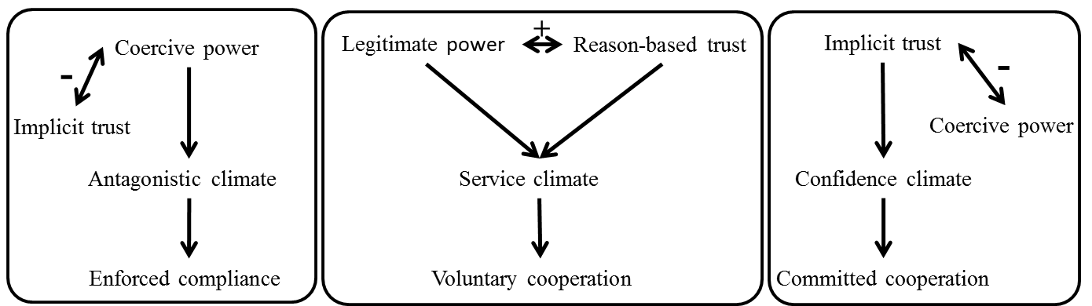

Figure 2: Structural equation models of the antagonistic model
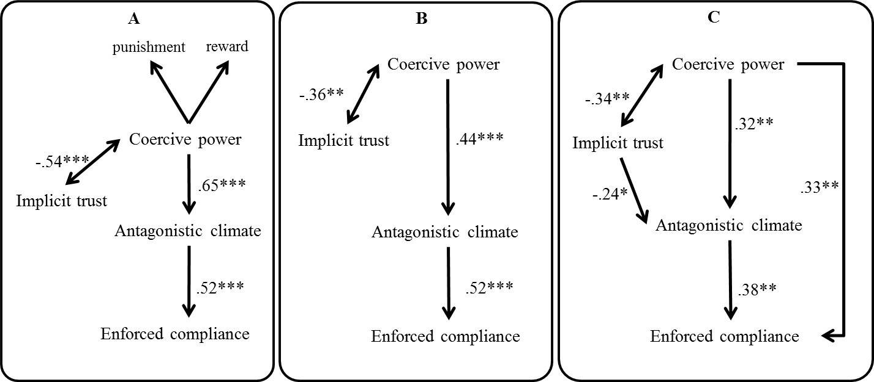

Figure 3: Structural equation models of the service model
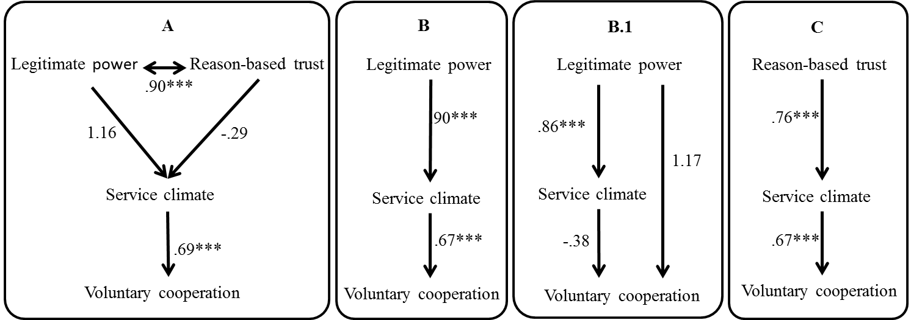

Figure 4: Structural equation models of the confidence model
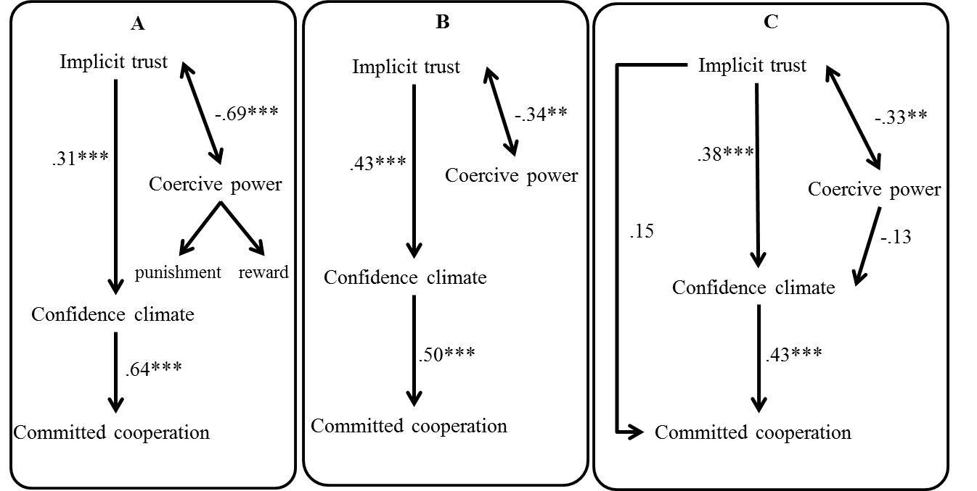

Appendix: Scales and items to assess power, trust, interaction climate, and tax compliance
Scales and Items | Factor-loadings | Reliability
Coercive Power |  | α = .77
The tax authority punishes severely. | .77
The tax authority enforces its demands through audits and fines. | .83
The tax authority prosecutes taxpayers mainly with audits and fines. | .88
Reward power |  | α = .80
The tax authority grants tax reliefs to taxpayers. | .84
The tax authority grants concessions to taxpayers in a number of ways. | .85
The tax authority rewards taxpayers in many ways. | .86
Legitimate Power |  | α = .75
The tax authority has the right to levy taxes from taxpayers because of its significance in the state. | .04
The tax authority is an institution taxpayers feel obliged to cooperate with, because of the good services in the past. | .57
The tax authority depends on taxpayers who fill out their tax forms correctly in order to work efficiently. | .54
The tax authority should especially receive diligently filled out tax returns from taxpayers whose past tax returns were too often completed incorrectly. | .42
The tax authority makes all taxpayers understand, which taxes they have to pay and to what extent they have to pay them. | .65
The tax authority informs taxpayers of possible errors occurring when completing their tax return. | .57
The tax authority does share understandable information. | .60
The tax authority knows how a correct tax return of each taxpayer has to look like. | .41
The tax authority knows how a correctly filled in tax return should look like. | .36
The tax authority is an expert on tax regulations and their practice. | .45
The tax authority is regarded for their work by the taxpayers. | .71
The tax authority is appreciated for their services by taxpayers. | .46
The tax authority is acknowledged for their work by taxpayers. | .57
Reason Based Trust |  | α = .92
I trust the tax authority because I agree with its main objectives. | .80
I trust the tax authority because its goals seem plausible. | .75
I trust the tax authority because I have no choice. | .22
I trust the tax authority because there is no alternative. | .30
I trust the tax authority because of its highly motivated employees. | .73
I trust in the tax authority because it has committed employees. | .74
I trust the tax authority because it provides competent work. | .75
I trust the tax authority because it is fulfilling its tasks well. | .80
I trust the tax authority because it behaves benevolently toward taxpayers. | .79
I trust the tax authority because it solely wants the best for taxpayers. | .72
I trust the TA because its decisions are politically supported. | .77
I trust in the tax authority because politics ensure that sufficient resources are available, so it can work. | .76
I trust the tax authority because the political situation ensures that the tax authority can work. | .81
I trust the tax authority because the economic stability guarantees that the tax authority can work. | .79
Implicit Trust |  | α = .92
I trust the tax authority usually without thinking about it. | .93
I trust the tax authority usually without dealing with it deeply. | .93
I trust the tax authority most of the time automatically. | .91
Antagonistic Climate |  | α = .88
Between the tax authority and taxpayers there exists a climate of inconsiderateness. | .91
Between the tax authority and taxpayers there exists a climate of ruthlessness. | .92
Between the tax authority and taxpayers there exists a climate of 'cops and robbers'. | .87
Service Climate |  | α = .87
Between the tax authority and the taxpayers there exists a climate that is characterized by the fact that the TA treats the taxpayer as their customer. | .90
The relationship between the tax authority and the taxpayers is similar to an enterprise and their customers. | .89
The relationship between the tax authority and taxpayers is service-oriented in nature. | .87
Confidence Climate |  | α = .91
The relationship between the tax authority and taxpayers is characterized by mutual trust. | .92
The relationship between the tax authority and taxpayers is characterized by joint responsibility. | .93
Between the tax authority and taxpayers there exists a climate of that is characterized by cooperation. | .91
Enforced Compliance |  | α = .84
When I pay taxes, I do so because a great many tax audits are carried out. | .88
When I pay taxes, I do so because I know I will be audited. | .89
When I pay taxes, I do so because the TA often carries out audits. | .91
When I pay taxes, I do so because I feel forced to pay my taxes. | .59
Voluntary Cooperation |  | α = .74
When I pay taxes, I do so because the tax authority will probably reciprocate my cooperation. | .84
When I pay taxes, I do so because the tax authority treats me correctly as long as I admit mistakes. | .83
When I pay taxes, I do so because the tax authority supports taxpayers who make unintentional mistakes. | .83
When I am paying my taxes correctly, I do so, because it is easier than to deceive the tax authority. | .52
Committed Cooperation |  | α = .92
When I pay taxes, I do so because it is the right thing to do. | .91
When I pay taxes, I do so because it is ultimately in everyone’s interest. | .89
When I pay taxes, I do so because I feel a moral obligation to pay taxes. | .90
When I am paying my taxes correctly, I do so, because it is an important civic duty. | .89

Raven, Schwarzwald, & Koslowsky (1998) call coercive power “harsh power” and legitimate power is called “soft power”. We stick to the terminology of regulation theory and use the terms coercive power and legitimate power (Tyler, 2006).

